How to combine multiple excel workbooks into one

Combining multiple Excel workbooks into one is useful because it allows easier data management and analysis by consolidating related information in a single file. Instead of navigating through multiple files, users can access all the data they need in one centralized location, saving time and effort.

Let's consider a scenario where we have two separate Excel workbooks: one containing sales data for Supercars and the other containing sales data for Common cars. To simplify the data analysis process, we aim to merge these workbooks into a single file. It is crucial to highlight that both files should adhere to the same format and be located within the same folder.

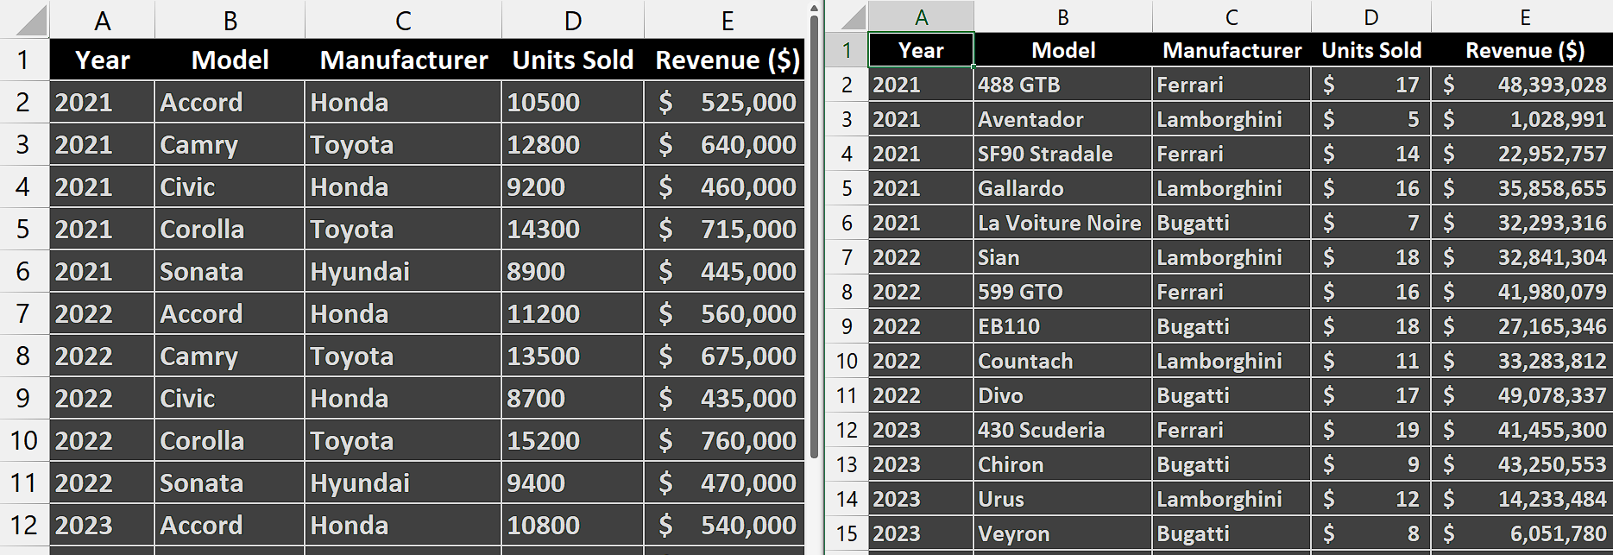

## Step 1 – Navigate to “Get Data” option

* Launch Microsoft Excel and open your desired workbook.
* Navigate to the "Data" tab located on the Excel ribbon.
* Look for the "Get Data" option in the "Get & Transform Data" section.
* Click on the "Get Data" option.



## Step 2 – Browse the folder containing files

* A drop-down menu will appear with various data source options.
* Move your move to the “From File” option and further options will appear.
* From those options, select the “From Folder” option.
* Then, browse and select the folder that contains the files we wish to combine.
* After that, click on “Open”.

## 

## Step 3 – Open the Power Query Editor

* After clicking on “Open”, a dialogue box will appear on your screen.
* Locate an option named “Combine” at the bottom of dialogue box.
* Click on the downward-arrow adjacent to it.
* Then choose the “Combine & Transform Data” option.
* Doing this will open another dialogue box.
* Just select the sheet you want to have as first sheet and click on “OK”.
* This will open the “Power Query Editor”.



## Step 4 – Modify the Data

* In the “Power Query Editor”, make necessary changes to your data.
* For instance, we are removing the “Source.Name” column for better appearance.



## Step 5 – Combine the data of two workbooks

* Locate the “Close and Load” option under the “Close” group in the “Power Query Editor”.
* Click on this option and the data of two workbooks will be combined in one file.

